<https://www.youtube.com/watch?v=2moCQeHCx-g>

Hyperledger Fabric SDK for Node.js

<https://fabric-sdk-node.github.io/release-1.4/index.html>

Commercial paper tutorial

<https://hyperledger-fabric.readthedocs.io/en/release-1.4/tutorial/commercial_paper.html>

Prerequisites

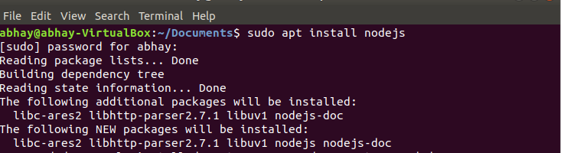

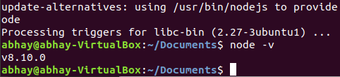

[**Node**](https://nodejs.org/en/about/) version 8.9.0, or higher.

Node is a JavaScript runtime that you can use to run applications and smart contracts.



[**Docker**](https://www.docker.com/get-started) version 18.06, or higher.

Hyperledger Fabric is provided as a set of Docker images.

$GOPATH is an important environment variable in Hyperledger Fabric; it identifies the root directory for installation.

Open a new terminal window and check your $GOPATH is set using the envcommand:



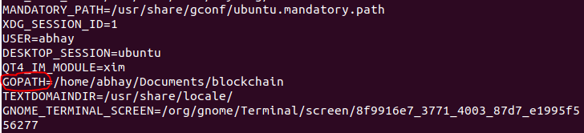

You can now create a directory relative to $GOPATHwhere fabric-samples will be installed:

$ mkdir -p $GOPATH/src/github.com/hyperledger/

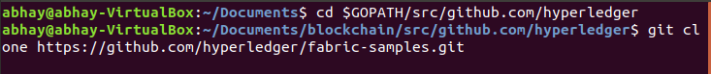



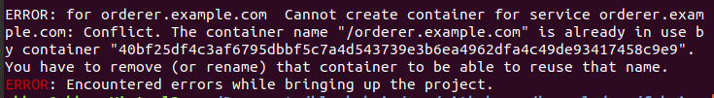

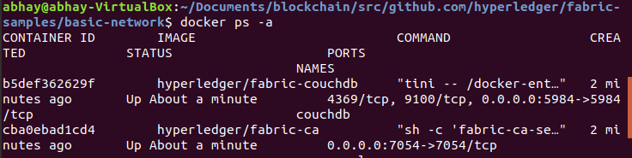

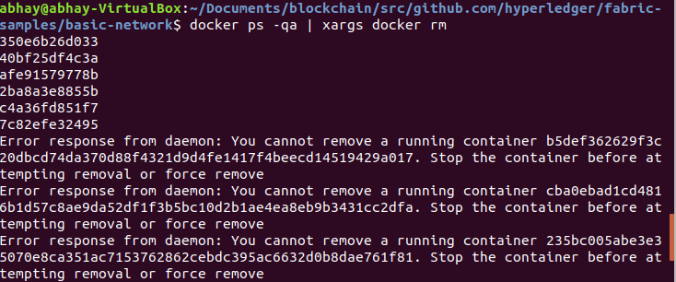

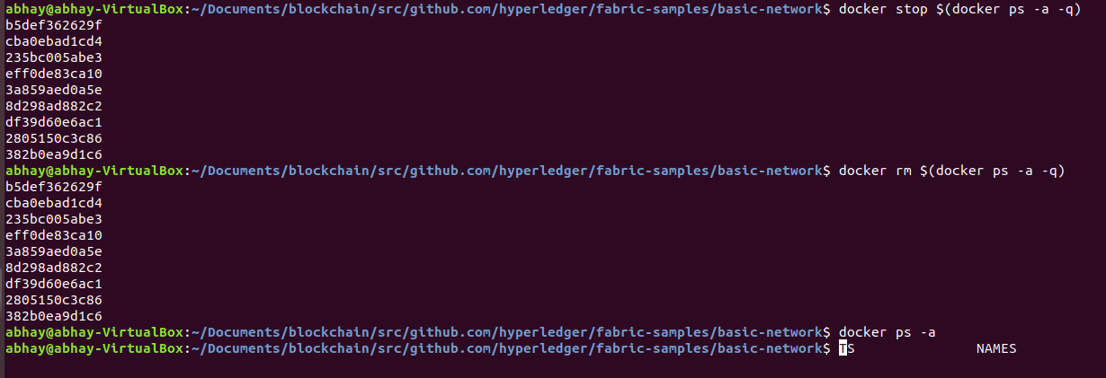

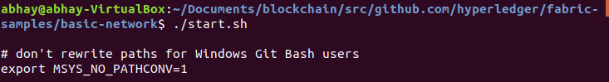

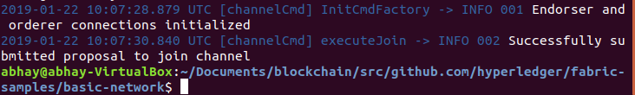

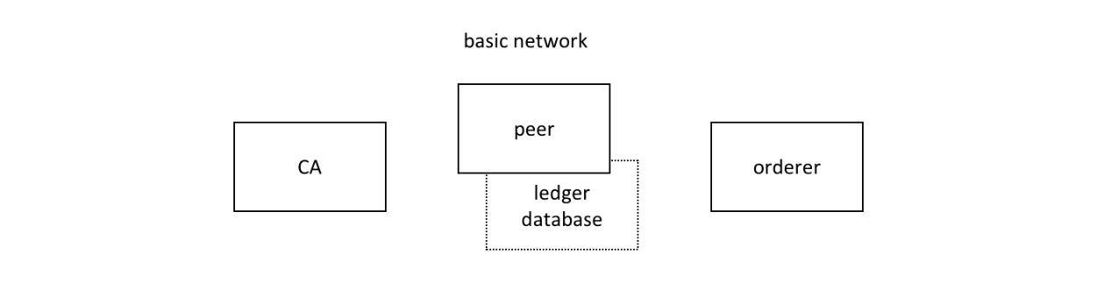

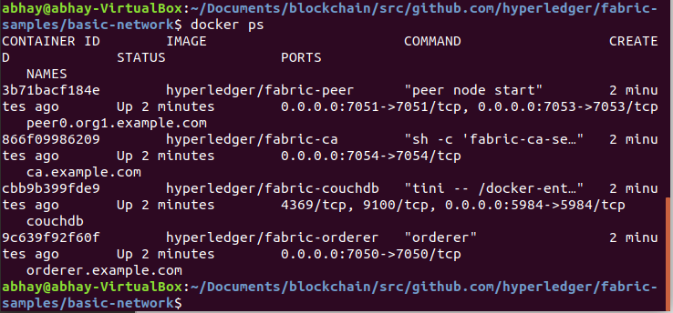

 You can view the network with the docker network command:

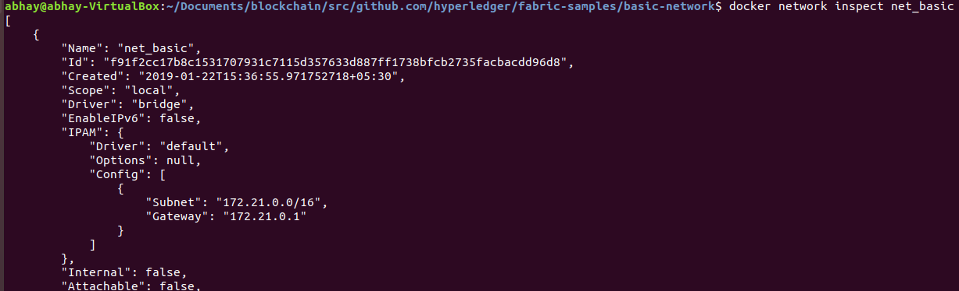

 Four containers use different IP addresses, while being part of a single docker network.

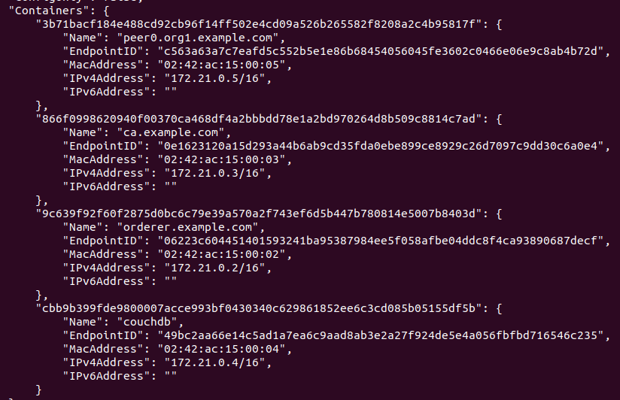

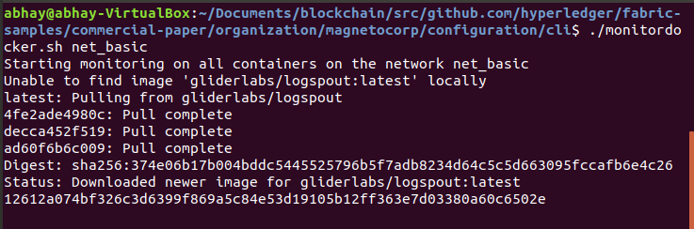

Another window

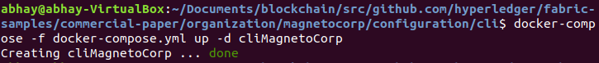

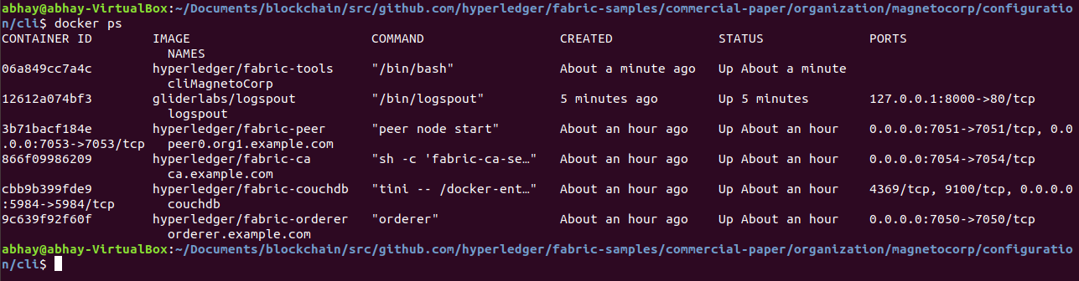

Smart contracts are the focus of application development, and are contained within a Hyperledger Fabric artifact called [chaincode](https://hyperledger-fabric.readthedocs.io/en/release-1.4/chaincode.html). One or more smart contracts can be defined within a single chaincode, and installing a chaincode will allow them to be consumed by the different organizations in PaperNet. It means that only administrators need to worry about chaincode; everyone else can think in terms of smart contracts.

Smart contract is installed on the peer and instantiated on a channel, papercontract can be invoked by applications, and interact with the ledger database via the [putState()](https://fabric-shim.github.io/release-1.3/fabric-shim.ChaincodeStub.html#putState__anchor) and [getState()](https://fabric-shim.github.io/release-1.3/fabric-shim.ChaincodeStub.html#getState__anchor) Fabric APIs.

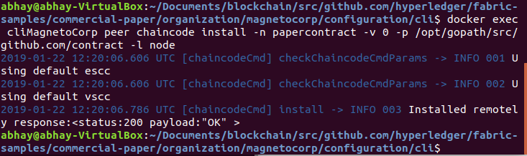

In another already opened window

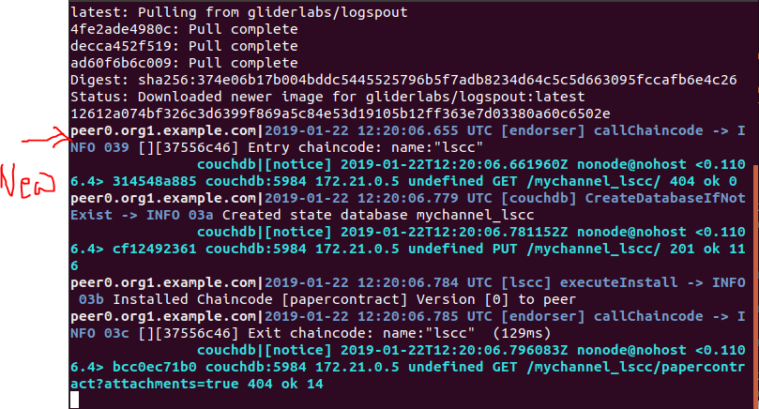

Instantiate

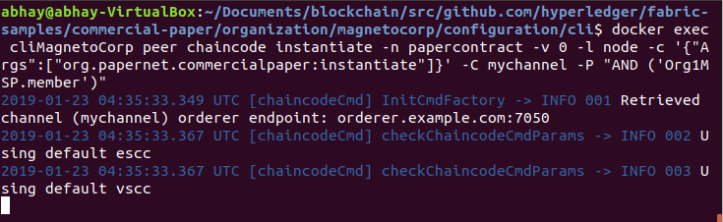

In another open window

